十年高考真题分类汇编（2010-2019） 英 语
专题25 语法填空
(2014﹒全国卷I)
Are you facing a situation that looking impossible to fix?
In 1969, the pollution is terrible along the Cuyahoga River near Cleveland, Ohio. It 61 (be)imaginable that it could be ever be cleaned up. The rive was so polluted that it 62 (actual) caught fire and burned. Now year late, this rive is one of63 most outstanding examples of environmental cleanup.
But river wasn’t changed in a few days 64 even a few months. It took years of work 65 (reduce) industrial pollution and clean the water. Finally, that hard work paid off and now the water in the river is 66 (clean) than ever.
Maybe you are facing an impossible situation. Maybe you have a habit 67 is driving your family crazy. Possibly you drink too much or don’t know how to control your credit card use. When you face such impossible situation, don’t you want a quick fix and something to change immediately.
While there are 68 (amaze) stories of instant transformation, for most of us the 69 (change) are gradual and require a lot of effort and work, like cleaning up a polluted river. Just be 70 (patience)
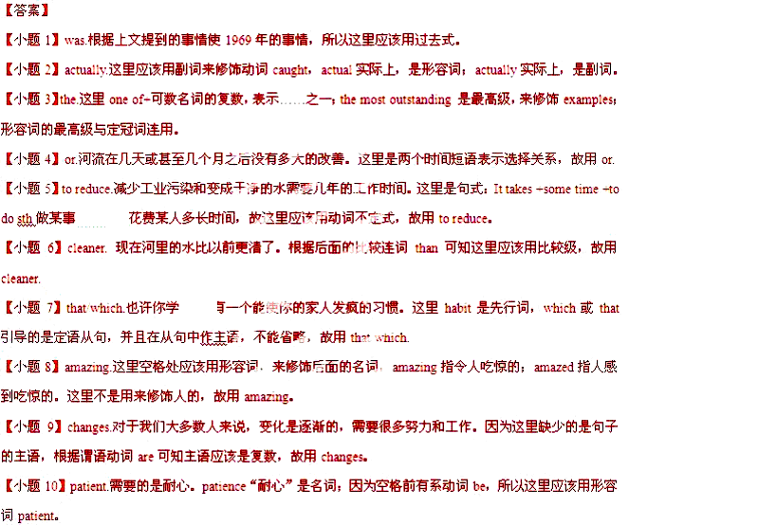
(2014﹒全国卷Ⅱ)
One morning , I was waiting at the bus stop , worried about 61 (be ) late for school ..There were many people waiting at the bus stop , 62 some of them looked very anxious and 63 (disappoint) .When the bus finally came , we all hurried on board .I got a place next 64 the window , so I had a good view of the sidewalk .A boy on a bike 65 (catch)my attention .he was riding beside the bus and waving his arms . I heard a passenger behind me shouting to the driver , but he refused 66 (stop ) until we reached the next stop .Still , the boy kept 67 (ride) . He was carrying something over his shoulder and shouting .Finally , when we came to the next stop , the boy ran up to the door of the bus . I heard an excited conversation .Then the driver stoop up and asked, “ 68 anyone lose a suitcase at the last stop ?” A woman on the bus shouted , “Oh dear “ It is 69 （I）”. She pushed her way to the driver and to the little boy .Everyone on the bus began talking about what the boy had done .And the passengers 70 （sudden）became friendly to one another .
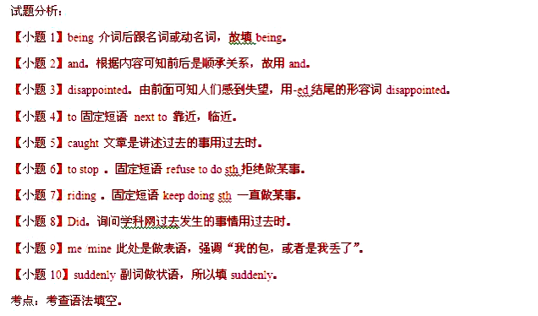
(2015﹒全国卷I)
Yangshuo, China
It was raining lightly when I 61 (arrive) in Yangshuo just be fore dawn. But I didn’t care. A few hours 62 , I’d been at home in Hong Kong, with 63_(it) choking smog. Here, the air was clean and fresh, even with the rain.
I’d skipped nearby Guilin, a dream place for tourists seeking the limestone mountain tops and dark waters of the Li River_64 are pictured by artists in so many Chinese _65 (painting). Instead, I ‘d head straight for Yangshuo. For those who fly to Guilin, it’s only an hour away 66_ car and offers all the scenery of the better-known city. Yangshuo 67 (be) really beautiful. A study of travelers_68 (conduct) by the website Trip Advisor names Yangshuo as one of the top 10 destinations in the world. And the town is fast becoming a popular weekend destination for people in Asia. Abercrombie & Kent, a travel company in Hong Kong, says it ( regular) arranges quick getaways here for people_70 (live) in Shanghai and Hong Kong.
【解析】 试题分析：本文是一篇记叙文。文章主要讲述了作者到中国阳朔游玩的经历和感受。
61. arrived 句意：就在天亮之前我到了阳朔，天下着小雨。根据前后句时态可知用一般过去时。
62. before/earlier 句意：几个小时前，我在香港家里。注意不可以用 ago。
63. its 句意：带着窒息的烟雾。后面为名词，故用 it’s。
64. that/which 句意：漓江被许多艺术家所绘画。考查定语从句。先行词为 Li River，在从句中作主语 .
65. paintings 句意：在如此多的中国绘画中。painting 为可数名词，注意用复数形式。
66. by 句意：乘汽车只需要 1 个小时。by car 乘汽车。
67. is 句意：阳朔真的很漂亮。这里用一般现在时。
68. conducted 句意：一项网站所进行的调查。过去分词作后置定语，表示被动关系。
69. regularly 句意：定期为人们安排这里适合旅行的地方。修饰动词，用副词修饰。
70. living 句意：住在上海和香港的人们。现在分词作后置定语。
(2015﹒全国卷Ⅱ)
The adobe dwellings (土坯房) 61 （build）by the Pueblo Indians of the American Southwest are admired by even 62 most modern of architects and engineers. In addition to their simple beauty, what makes the adobe
dwellings admirable is their 63 (able) to “air condition” a house without 64 ( use) electric equipment. Walls made of adobe take in the heat from the sun on hot days and give out that heat 65 ( slow) during cool nights, thus warming the house. When a new day breaks, the walls have given up their heat and are now cold enough 66 (cool) the house during the hot day; 67 the same time, they warm up again for the night. This cycle 68 (go) day after day: The walls warm up during the day and cool off during the night and are thus always a timely offset(抵消) for the outside temperatures. As 69 (nature) architects, the Pueblo Indians figured out exactly 70 thick the adobe walls needed to be to make the cycle work on most days.
【解析】 试题分析：土坯房比现在的房子好在冬暖夏凉。现代的建筑师都很羡慕这样的房子不用空调就能很好地调 节室内的温度，不过关键是这房子的墙的厚度。
61.built 动词 build 和定语 The adobe dwellings 是逻辑上的动宾关系，所以用其过去分词 built 和后面的 by一起做定语。
62.the 形容词最高级 most modern 前加 the。
63.ability 代词 their 后接名词，所以用 able 的名词形式 ability.
64.using 介词 without 后接动名词 use 去掉字母 e 再加-ing。
65.slowly 用 slow 的副词形式 slowly 修饰动词 give out.
66.to cool 形容词加 enough 后接不定式。
67.at at the same time 是固定词组。
68.goes 根据上下文，此处用一般现在时态。这种循环日复一日。
69.natural 形容词做定语修饰名词 architects。
70.how 根据句意，应用 how 修饰形容词 thick，连接宾语从句。
(2016﹒全国新课标I) 阅读下面材料，在空白处填入适当的内容（1个单词）或括号内单词的正确形式。
Chengdu has dozens of new millionaires, Asia’s biggest building, and fancy new hotels. But for tourists like me, pandas are its top____61_(attract).
So it was a great honour to be invited backstage at the not-for-profit Panda Base, where ticket money helps pay for research, I_____62_（allow）to get up close to these cute animals at the 600-acre centre. From tomorrow, I will be their UK ambassador. The title will be __63___(official) given to me at a ceremony in London.But my connection with pandas goes back ____64__ my days on a TV show in the mid-1980s, ____65_ I was the first Western TV reporter__66___ (permit) to film a special unit caring for pandas rescued from starvation in the wild. My ambassadorial duties will include ____67_(introduce) British visitors to the 120-plus pandas at Chengdu and others at a research in the misty mountains of Bifengxia.
On my recent visit, I help a lively three-month-old twin that had been rejected by _____68_ (it) mother. The nursery team switches him every few __69__( day) with his sister so that while one is being bottle-fed, __70____ other is with mum-she never suspects.
【解析】61. attraction 62. was allowed 63. officially 64. to 65. when
66. permitted 67. introducing 68. its 69. days 70. the
试题分析:本文是- -篇记叙文。讲述了作者作为特邀人员在四川成都的大熊猫基地的所见所闻。61. ataction考查名词。 形容词top后面跟名词形式。
62. was allowveld考查时态和语态。根据句意可知作者是被允许走近这些动物，be allowed to do sth'被允许做某事”。
63. oicialt考查副词。修饰动词用副词形式。64.10考查介词。 固定短语: go back to“回到”。
65. when考查定语从句。后面是非限制性定语从句，从句缺少状语，因为先行词是时间，故填when。
66. permitted 考查过去分词。被修饰的名词和permit之间是被动关系，用过去分词。
67. introducing考查动名词。 介词后面应该用动名词形式。
68. its考查代词。 修饰名词用形容词性的物主代词，故填its。
69. days考查名词复数。Few修饰复数名词。
70. the考查冠词。固定短语：one …the other“一个……另一个”。
(2016﹒全国新课标III) 阅读下面材料，在空白处填入适当的内容（1个单词）或括号内单词的正确形式。
In much of Asia,especially the so-called＂rice bowl＂ cultures of China,Japan,Korea, 41 Vietnam,food is usually eaten with chopsticks.
Chopsticks are usually two long,thin pieces of wood or bamboo.They can also be made of plastic,animal bone or metal.Sometimes chopsticks are quite artistic.Truly elegant chopsticks might 42 (make)of gold and silver with Chinese characters.Skilled workers also combine various hardwoods and metal 43 (create)special designs.
The Chinese have used chopsticks for five thousand years.People probably cooked their food in large pots, 44 (use)twigs(树枝)to remove it.Over time, 45 thepopulation grew,people began cutting food into small pieces so it would cook more quickly.
Food in small pieces could be eaten easily with twigs which 46 (gradual)turned into chopsticks.
Some people think that the great Chinese scholar Confucius, 47 lived from roughly 551 to 479 B.C.,influenced the 48 (develop)of chopsticks.Confucius believed knives would remind people of killings and 49 (be)too violent for use at the table.
Chopsticks are not used everywhere in Asia.In India,for example,most people traditionally eat 50 their hands.
【解析】41.and
42.be made
43.to create
44.using
45.as/when
46.gradually
47.who
48.development
49.were
50.with
41. .and考查并列连词。这里列举了- -些亚洲的国家，它们是并列关系，故填and。
42. be made考查固定词组。sth be made of精美的筷子可能非由金或银制成的筷子莫属..某物由.制成，情态动词后跟动词原形，故填be made
43.to create考查不定式作目的状语。技术娴熟的工人会把各种各样的硬质木材和金属结合起来,以创造出特殊风格的筷子。这里用不定式表目的，故填to create。
44. using考查现在分词作伴随状语。人们可能使用大锅煮食物用树枝把锅移开, use的逻辑主语是people,两者是主动关系,用现在分词表示伴随状况，故填using。
45. aswben考查时间状语从句。句意:随着人口的增长，人们开始把食物切成小块,这样可以煮得快一点，这里是时间状语从句，wben 意为.时候”，后跟长动作或短动作，故填as/ wben。
46.gradually考查副词。副词修饰动词或形容词，这里修饰动词短语turned into，应该用副词，故填gradually。
47.who考查非限制性定语从句。剧中有逗号，说明是非限制性定语从句，先行词是Confucius孔子，定语从句缺少主语，且指人，故填who。
48.development考查词性转换。the＋名词＋of，意为“……的……”，这里指“筷子的发展”，故填development。
49.were考查时态。根据句意可知，这里指的是刀子因太暴力而不适合在餐桌上使用，believed后跟一个宾语从句，and连接了两个并列的谓语，主语knives是复数，根据时态一致的原则，这里用一般过去时，故填were。
50.with考查介词。句意：在印度，大部分人还是用传统的吃饭方法－－用手拿，with＋表示具体工具的名词，故填with。
(2016﹒四川) 阅读下面材料，在空白处填入适当的内容（1个单词）或括号内单词的正确形式。
The giant panda 41 (love) by people throughout the world.Chinese scientists 42 (recent) had a chance to study a wild female panda with a newborn baby.She was a very 43 (care)mother.For 25days,she never left her baby,not even to find something 44 (eat)!She would not let any other pandas come near.She licked the baby constantly to keep it clean.Any smell might attract natural 45 (enemy)that would try to eat the little comforting pats.The mother held the baby in her front paws much the way a human does. 46 it cried,she rocked it back and forth and gave it little comforting pats,The mother continued to care for the young panda 47 more than two years.By that time,the panda no longer needed 48 (it)mother for food.However,it stayed with her and leaned about the ways of the forest.Then,after two and a half years,the mother 49 (drive)the young panda away.It was time for her to have a new baby,50 it was also time for the young panda to be independent.
【解析】41.is loved 42.recently 43.caring/careful 44.to eat 45.enemies
- When/If 47.for 48.its 49.drove 50.and
试题分析:本文讲的是妈妈熊猫和她的孩子的故事。
41.is loved句意:大熊猫被全世界的人喜欢。根据句意可知用-般现在时态的被动语态, The giant panda是单数第三人称形式，故填is loved .
42.recently副词修饰动词，故填recenty。
43.caring/careful 此处是现在分词或形容词作定语，放在名词前面，故填caring/careful。
44.to eat 句意：甚至不去找吃的东西。此处是动词不定式放在不定代词后面作后置定语，故填to eat。
45.enemies 句意：任何气味都可能吸引自然界的敌人。自然界的敌人不止一个，应该用复数形式，故填enemies。
46.When/If 句意：如果或当它哭的时候，她会前后摇动。故填When/If。
47.for 句意：妈妈继续照顾小熊猫两年多。此处表示一段时间，故填for。
48.its 句意：小熊猫不再需要它妈妈的食物。形容词性物主代词修饰名词，故填its。
49.drove 句意：然后，两年半后妈妈让小熊猫离开。根据句意可知用一般过去时态，故填drove。
50.and 句意：现在是她该有一个小宝宝的时间了，同时也是小熊猫该独立的时间了。此处表示并列，是一个并列句，故填and。

(2017﹒新课标Ⅰ)
阅读下面短文，在空白处填入 1个适当的单词或括号内单词的正确形式。
There has been a recent trend in the food service industry toward lower fat content and less salt. This trend, which was started by the medical community（医学界） 61 a method of fighting heart disease, has had some unintended side 62 (effect) such as overweight and heart disease—the very thing the medical community was trying to fight.
Fat and salt are very important parts of a diet. They are required 63 (process) the food that we eat, to recover from injury and for several other bodily functions. When fat and salt 64 (remove) from food, the food tastes as if is missing something. As 65 result, people will eat more food to try to make up for that something missing. Even 66 (bad), the amount of fast food that people eat goes up. Fast food 67 (be) full of fat and salt; by 68 (eat) more fast food people will get more salt and fat than they need in their diet.
Having enough fat and salt in your meals will reduce the urge to snack(吃点心) between meals and will improve the taste of your food. However, be 69 (care) not to go to extremes. Like anything, it is possible to have too much of both, 70 is not good for the health.
【解析】
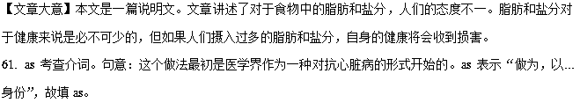62. effects 考查单复数。分析语境可知作者表达的意思是“一些不为人知的副作用”，根据前文的some可知“副作用side effect”有很多，故填effects。
63. to process 考查不定式。句意：他们被要求加工食物 require表示“要求”， require sb. to do sth.表示“要求某人做某事”，被动形式为“sb. be required to do sth.”，表示“某人被要求做某事”。故填to process。
64. are removed 考查被动语态。句意：当脂肪和盐分从食物中被去掉 分析可知fat，salt和move之间是被动关系，脂肪和盐分是被人们去掉，所以用被动语态。故填are removed。
65. a 考查冠词。固定短语as a result表示“结果”，句意：结果，人们将吃更多的食物去弥补损失的东西。故填a。
66. worse 考查比较级。句意：更糟糕的是，人们所吃快餐的数量增加了。故填worse。
67. is 考查主谓一致。句意：快餐食物中充满了脂肪和盐。fast food的意思是“快餐”，表示一类食物，为不可数名词，谓语动词用单数形式。故填is。
68. eating 考查动名词。句意：通过吃更多的快餐，人们将在饮食中摄入超过需求量的脂肪和盐。根据前文中的by可知此处应该填名词，所以填eat的动名词形式。故填eating。
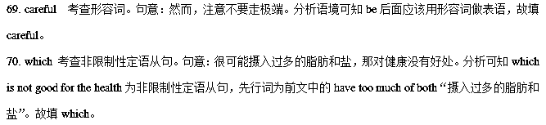

(2017﹒全国卷Ⅱ)
阅读下面短文，在空白处填入1个适当的单词或括号内单词的正确形式。
In 1863the first underground passenger railway in the world opened in London. It ran for just under seven kilometers and allowed people to avoid terrible __61__(crowd) on the roads above as they travelled to and ___62__ word. It took three years to complete and was built using an interesting method. This included digging up the road, ____63___(lay) the track and then building a strong roof over___64___ top. When all those had been done, the road surface was replaced.
Steam engines ___65__(use) to pull the carriages and it must have been___66__(fair)unpleasant for the passengers, with all the smoke and noise. However, the railway quickly proved to be a great success and within six months, more than 25,000 people were using___67__ every day.
Later, engineers ____68___(manage) to construct railways in a system of deep tunnels (隧道）, which became known to the tube. This development was only possible with the ___69___ (introduce) of electric-powered engines and lifts. The central London Railway was one of the most ___70___(success) of these new lines, and was opened in 1900. It had white-painted tunnels and bright red carriages, and proved extremely popular with the public.
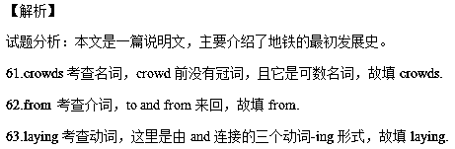
64.the考查名词，top是名词，前要用冠词，故填the.
65.were used考查被动语态，根据句意：蒸汽发动机“被用于”拉货物，故填were used.
66.fairly 考查副词，这里fair是形容词，pleasant也是形容词，所以需要将fair变为副词来修饰形容词，故填fairly.
67.it考查代词，这里用it指代前句的railway,故填it.
68.managed 考查动词，本文全篇都是一般过去时，所以这里也应用一般过去时，故填managed.
69.introduction考查词性转换，空格前是the,后面应该是名词，故填名词introduction.
70.successful考查形容词，空格前是most,其后要跟形容词构成最高级，故填successful.
(2017﹒全国卷Ⅲ)
阅读下面短文，在空白处填入 1个适当的单词或括号内单词的正确形式。
She looks like any other schoolgirl, fresh-faced and full of life. Sarah Thomas is looking forward to challenge of her new A-level course .But unlike school friends ,16-year-old Sarah is not spending half-term 61 (real)Instead, she is earning $6500 a day as 62 model in New York.
Sarah 63 (tell) that she could be Britain’s new supermodel earning a million dollars in the new year. Her father Peter44,want her to give up school to model fulltime But Sarah, 64 has taken part in shows along with top models wants 65 (prove) that she has brains as well as beauty she is determined to carry on with her 66 (educate).
She has turned down several 67 (invitation) to star at shows in order to concentrate on her studies After school she plans to take a year off to model full time before going to university to get a degree 68 engineering or architecture.
Sarah says, "My dad thinks I should take the offer now. But at the moment, school 69 (come) first. I don't want to get too absorbed in modeling. It is 70 (certain) fun but the lifestyle is a little unreal. I don't want to have nothing else to fall back on when I can't model my more."
【解析】本文是一篇人物类记叙文，介绍了Sarah Thomas在学业和诱人的职业面前所做出的选择，她认为在青少年时期学业要放在首位。
61. resting考查非谓语动词。 固定短语：spend time doing sth
62. a考查冠词。 model是可数名词，前面没有限定词，而此处泛指 “一个”，故填a。
63. was told 考查动词。根据句意判断谓语动词应该用一般过去时的被动形式，主语Sarah是第三人称单数，故填was told。

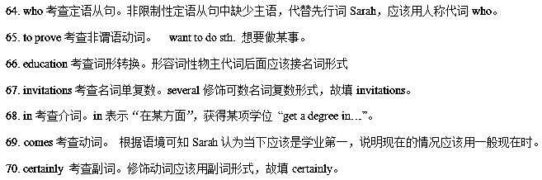
(2017﹒浙江)
阅读下面材料，在空白处填入适当的内容（1个单词）或括号内单词的正确形式。
Last October , while tending her garden in Mora , Sweden , Lena Pahlsson pulled out a handful of small 56 (carrot) and was about to throw them away. But something made her look closer , and she noticed a 57 (shine) object. Yes, there beneath the leafy top of one tiny carrot was her long-lost wedding ring.
Pahlsson screamed 58 loudly that her daughter came running from the house. “she thought I had hurt 59 (I),”says Pahlsson
Sixteen years 60 (early), Pahlsson had removed the diamond ring 61 (cook) a meal. When she wanted to put the ring back on later, it was gone. She suspected that one of her three daughters —then ten, eight, and six— had picked it up, but the girls said they hadn't. Pahlsson and her husband 62 (search) the kitchen, checking every corner, but turned up nothing. “I gave up hope of finding my ring again," she says. She never replaced it.
Pahlsson and her husband now think the ring probably got 63 (sweep) into a pile of kitchen rubbish and was spread over the garden, 64 it remained until the carrot’s leafy top accidentally sprouted (生长) through it. For Pahlsson, its return was 65 wonder.
【解析】本文是一篇记叙文。主要讲述了Lena Pahlsson在花园里采摘胡萝卜时，找到了丢失已久的结婚戒指的那种失而复得心情。
- 考查名词。根据“one tiny carrot was her long-lost wedding ring.”，及“a handful of ”，可知用名词复数，故填carrots。
- 考查形容词。“she noticed a 57 (shine) object”a为冠词，object为名词，横线处应填写形容词。故填shiny或shining。
- 考查固定句式。根据“Pahlsson screamed 58 loudly that her daughter came running from the house”，so…that,如此…以至于，故填so。
- 考查代词。I had hurt 59 (I)，主语为I,横线处为宾语，替代主语时，应用代词。故填myself。
- 考查形容词。says Pahlsson Sixteen years 60 (early)，用形容词比较级修饰Sixteen years，Sixteen years earlier16年前；故填earlier。
- 考查动词不定式。Pahlsson had removed the diamond ring 61 (cook) a meal，一个句子不能出现双重谓语，所以用不定式表目的状语。故填to cook。
- 考查动词时态。根据“but turned up nothing”，可知句子为过去时，“Pahlsson and her husband 62 (search) the kitchen”故填searched。
- 考查动词。 “Pahlsson and her husband now think the ring probably got 63 (sweep) into a pile of kitchen rubbish”，ring与sweep之间是被动关系，故填swept。
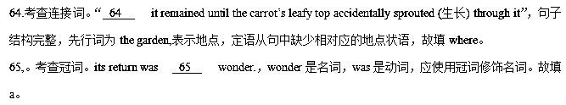
(2018﹒全国卷Ⅰ)
阅读下面短文，在空白处填入1个适当的单词或括号内单词的正确形式。
According to a review of evidence in a medical journal, runners live three years ___61___(long) than non-runners. You don't have to run fast or for long___62___(see)the benefit. You may drink, smoke, be overweight and still reduce your risk of ___63___ (die) early by running. While running regularly cann't make you live forever, the review says it ___64___ (be) more effective at lengthening life___65___ walking, cycling or swimming. Two of the authors of the review also made a study published in 2014___66___showed a mere five to 10 minutes A day of running reduced the risk of heart disease and early deaths from all ___67___(cause).
The best exercise is one that you enjoy and will do. But otherwise… it's probably running. To avoid knee pain, you can run on soft surfaces, do exercises to___68___(strength)your leg muscles(肌肉),avoid hills and get good running shoes. Running is cheap, easy and it's always___69___(energy).If you are time poor, you need run for only half the time to get the same benefits as other sports, so perhaps we should all give___70___a try.
【解析】61. longer
62. to see 63. dying
64. is 65. than
66. that \which
67. causes 68. strength
69. energetic
70. it \running
本文是一篇说明文。文章讲述了跑步的好处，它可以帮助人们延年益寿。
61. 考查副词的比较级。医学报告显示：经常跑步的人比不跑步的人多活3年。根据than可知用比较级，故填longer。
62. 考查不定式作目的状语。你不必跑地太快或时间太长就能看到它的好处。此处不定式作目的状语，故填to see。
63. 考查动名词。你也许喝酒、吸烟或超重，但仍然通过跑步会减少早亡的风险。此处of是介词，其后用动名词。故填dying。
64. 考查动词的时态。医学报告显示：跑步比散步、骑车和游泳更能有效地延长寿命。这里叙述的是一个事实，故用一般现在时。故填is。
65. 考查比较句型。跑步比散步、骑车和游泳更能有效地延长寿命。根据文章中的more effective可知此处填than。
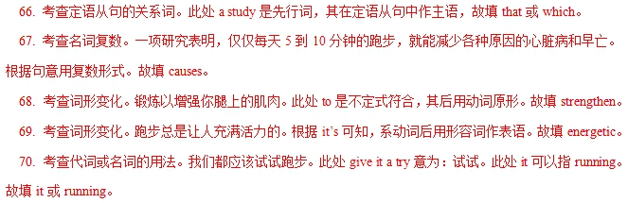
(2018﹒全国卷Ⅱ)
阅读下面短文，在空白处填入1个适当的单词或括号内单词的正确形式。
Diets have changed in China — and so too has its top crop. Since 2011,the country ___61___（grow）more corn than rice. Corn production has jumped nearly 125 percent over ___62___ past 25 years, while rice has increased only 7 percent.
A taste for meat is ___63___ (actual) behind the change: An important part of its corn is used to feed chickens, pigs, and cattle. Another reason for corn's rise: The government encourages farmers to grow corn instead of rice ___64___ (improve) water quality. Corn uses less water ___65___ rice and creates less fertilizer(化肥) runoff. This switch has decreased ___66___ (pollute) in the country's major lakes and reservoirs and made drinking water safer for people.
According to the World Bank, China accounts for about 30 percent of total ___67___ (globe)fertilizer consumption. The Chinese Ministry of Agriculture finds that between 2005—when the government ___68___ (start) a soil-testing program ___69___ gives specific fertilizer recommendations to farmers - and 2011, fertilizer use dropped by 7.7 million tons. That prevented the emission(排放) of 51.8 million tons of carbon dioxide. China's approach to protecting its environment while ___70___ (feed) its citizens "offers useful lessons for agriculture and food policymakers worldwide." says the bank's Juergen Voegele.
【解析】61. has grown
62. the 63. actually
64. to improve
65. than 66. pollution
67. global 68. started
69. that/which
70. feeding
本文是一篇说明文。文中讲述了中国为保护环境在农作物种植上做了一些变化并得到了世界上的知名认识的认可。
61. 考查时态。since加时间点，主句要用现在完成时。句意：2011年以来，中国种植的玉米比水稻多。故填has grown。
62. 考查冠词。句意：玉米产量在过去25年里增长了近125%，而大米只增长了7%。故是特指在过去的25年里。故填the。
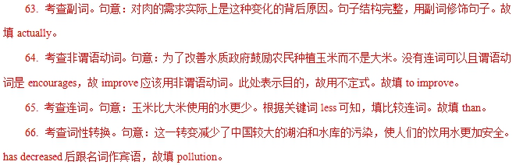 67. 考查词性转换。句意：中国约占全球化肥总消费量的30%。fertilizer consumption是名词短语，故应该用形容词修饰。故填global。
68. 考查谓语动词。句意：在2005年政府开始了一项土壤测试项目。本句是when引导的定语从句，由于时间是2005年，故用过去时。故填started。
69. 考查定语从句关系词。根据空后的谓语动词gives可知，该空缺少主语，指代program并且引导后面的句子。指物用that/which，故填that或者which。
70. 考查省略句。句意：中国在养活了中国人民的同时又保护了环境。这一做法为全世界的农业和粮食政策制定人提供了很有用的经验。空格处表示正在进行的动作，while后面省略掉了China is，省略句的原则：在时间状语从句、条件状语从句、，让步状语从句中，如果从句的主语和主句的主语一致且含有be动词时，那么可以把主语和be动词一块省略。故填feeding。
(2018﹒全国卷Ⅲ)
阅读下面短文，在空白处填入1个适当的单词或括号内单词的正确形式。
I'm not sure _____61_____ is more frightened, me or the female gorilla(大猩猩）that suddenly appears out of nowhere. I'm walking on a path in the forest in the Central African Republic. Unexpectedly, I'm face-to-face with the gorilla, who begins screaming at ____62____ top of her lungs. That makes her baby scream, and then a 400-pound male appears. He screams the
___63___(loud)of all. The noise shakes the trees as the male beats his chest and charges toward me. I quickly lower myself, ducking my head to avoid ____64____(look) directly into his eyes so he doesn't feel____65____(challenge).
My name is Mireya Mayor. I'm a ___66___(science)who studies animals such as apes and monkeys. I was searching ___67___ these three western lowland gorillas I'd been observing. No one had seen them for hours, and my colleagues and I were worried.
When the gorillas and I frightened each other, I was just glad to find ____68____(they) alive. True to a gorilla's unaggressive nature, the huge animal ____69____(mean)me no real harm. He was just saying: "I'm king of this forest, and here is your reminder!" Once his message was delivered, he allowed me ____70____ (stay)and watch.
【解析】61. which
62. the 63. loudest
64. looking
65. challenged
66. scientist
67. for 68. them
69. meant 70. to stay
本文为记叙文。文章主要讲述了作者在中非偶遇大猩猩，彼此惊恐的经历。
61. 考查宾语从句。句意：我不确定哪一个更害怕，我，还是突然出现的雌性大猩猩。此处为宾语从句，空格处表示选择，所以用which表示“哪一个”
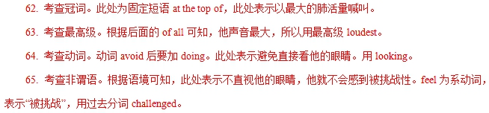
66. 考查名词。根据语境可知，我是一名科学家。scientist科学家。
67. 考查动词短语搭配。search for是固定搭配，表示“寻找”，表示“我”在寻找“我”研究的三只西部低地大猩猩。
68. 考查代词。此处做find 的宾语，所以用宾格them。
69. 考查谓语动词。分析本句的句子成分可知，本句缺少谓语，再根据总体时态可知要用一般过去时，所以用meant。
70. 考查非谓语动词。固定短语allow sb to do允许某人做某事，应该用to stay。
(2018﹒浙江)
阅读下面材料，在空白处填入适当的内容（1个单词）或括号内单词的正确形式。
Few people I know seem to have much desire or time to cook. Making Chinese ___56___(dish) is seen as especially troublesome. Many westerners ___57___ come to China cook much less than in their own countries once they realize how cheap ___58___ can be to eat out. I still remember ___59___ (visit) a friend who’d lived here for five years and I ___60___(shock) when I learnt she hadn’t cooked once in all that time.
While regularly eating out seems to ___61___(become) common for many young people in recent years, it’s not without a cost. The obvious one is money; eating out once or twice a week may be ___62___(afford) but doing this most days adds up. There could be an even ___63___ (high) cost on your health. Researchers have found that there is a direct link between the increase in food eaten outside the home and the rise in ___64___(weigh) problems.
If you are not going to suffer this problem, then I suggest that the next time you go to your mum’s home ___65___ dinner, get a few cooking tips from her. Cooking food can be fun. You might also begin to notice the effects not only on your health but in your pocket.
【解析】56. dishes
57. who/that
58. it 59. visiting
60. was shocked
61. have become
62. affordable
63. higher 64. weight
65. for
作者描述了人们喜欢在外面吃饭的现象，分析了其对身体和花费的不良影响，建议我们在家做饭。
56. 考查名词。此处指中国菜，表示泛指应该用名词复数，故填dishes。
57. 考查关系代词。句中包含定语从句，先行词是westerners指人，在定语从句中做主语，用关系代词who/that引导，故填who/that。
58. 考查it用法。句子为感叹句，正常语序应该是it can be cheap to eat out.其中不定式to eat out是真正主语，用it 是形式主语。故填i。
59. 考查动词形式。此处指我记得去拜访一个在这里住了五年的朋友，表示记得做过某事用remember doing sth.，故填visiting。
60. 考查形容词。此处表示我感到很震惊。shock的主语是I,用形容词和系动词组成系表结构，表示过去发生的事，系动词用过去式。故填was shocked。
61. 考查动词时态。根据时间状语in recent years可知用现在完成时，seems to后用动词原形，故填have become。
62. 考查形容词。此处表示一周一两次外出吃饭是负担得起的，系动词be后用形容词作表语，表示“负担得起的”故填affordable。
63. 考查形容词比较级。此处修饰名词cost用形容词，由even表示程度修饰比较级，故填higher。
64. 考查名词。此处指体重问题，用名词修饰problems，故填weight。
65. 考查介词。表示去母亲家去吃饭，表示目的用介词for，故填for。
(2019﹒全国卷Ⅰ)
阅读下面短文，在空白处填入1个适当的单词或括号内单词的正确形式。
The polar bear is found in the Arctic Circle and some big land masses as far south as Newfoundland. While they are rare north of 88°,there is evidence ___61___ they range all the way across the Arctic, and as far south as James Bay in Canada. It is difficult to figure out a global population of polar bears as much of the range has been ___62___ (poor) studied; however, biologists calculate that there are about 20,000-25,000 polar bears worldwide.
Modem methods ___63___ tracking polar bear populations have been employed only since the mid-1980s, and are expensive ___64___ (perform) consistently over a large area. In recent years some Inuit people in Nunayut ___65___ (report) increases in bear sightings around human settlements, leading to a ___66___ (believe) that populations are increasing. Scientists have responded by ___67___ (note) that hungry bears may be congregating(聚集) around human settlements, leading to the illusion(错觉) that populations are ___68___ (high) than they actually are. Of ___69___ nineteen recognized polar bear subpopulations, three are declining, six ___70___ (be) stable, one is increasing, and nine lack enough data.
【解析】本文为科普文类说明文，介绍了北极熊的生存现状。
61. 考查同位语从句。根据句子结构分析可知，主句为there be句型，且结构完整，空格后为同位语从句，解释说明中心词evidence的内容，故填that。
62. 考查副词用法。根据句意和结构分析可知，此处用副词poorly修饰谓语动词has been studied，意为“研究很少”。故填poorly。
63. 考查介词用法。此处tracking polar bear populations作Modern methods的定语，用of 连接，“methods of doing sth.”,意为“……的方法”，构成固定结构。或者意为“对于跟踪北极熊的方法”用for。故填of/for。
64. 考查非谓语动词。主系表结构之后，常用不定式作原因或目的状语，句意：跟踪北极熊的现代方法只是在二十世纪八十年代以来开始采用，并且在如此大区域内持续采用是昂贵的，故此处用to perform。
65. 考查时态。根据上下文语境，尤其是时间状语in recent years可知，主句用现在完成时态，故填have reported。
66. 考查名词。根据其前不定冠词和其后的同位语从句可知，空格处为名词形式，故填belief。
67. 考查非谓语动词。根据其前介词by可知，此处用动名词主动形式，故填noting。
68.
【解析】考查形容词比较级。根据其后than they actually are可知，此处为形容词的比较级，故填higher。
69. 考查定冠词。此处为特指，意为“在已知的19个北极熊亚种群中”，故填the。
70. 考查主谓一致。根据three are declining，此处数词six作主语，代指前文中的“polar bear subpopulations”，故用复数谓语，一般现在时，故填are。
(2019﹒全国卷Ⅱ)
阅读下面短文，在空白处填入1个适当的单词或括号内单词的正确形式。
A 90-year-old has been awarded “Woman Of The Year”for ___61___ (be)Britain's oldest full-time employee-still working 40 hours a week. Now Irene Astbury works from 9am to 5pm daily at the pet shop in Macclesfield, ___62___ she opened with her late husband Les. Her years of hard work have ___63___(final)been acknowledged after a customer nominated(提名)her to be Cheshire's Woman Of The Year.
Picking up her “Lifetime Achievement” award，proud Irene ___64___(declare) she had no plans ___65___ (retire) from her 36-year-old business. Irene said，“I don't see any reason to give up work. I love coming here and seeing my family and all the friends I ___66___(make) over the years. I work not because I have to, ___67___ because I want to.”
Granddaughter Gayle Parks，31-who works alongside her in the family business-said it remained unknown as to who nominated Irene for the award. She said，“We don't have any idea who put grandma forward. When we got a call ___68___ (say)she was short-listed，we thought it was ___69___ joke. But then we got an official letter and we were blown away. We are so proud of her. It's ___70___ (wonder).”
【解析】本文为记叙文。讲述了九十高龄的Irene作为英国最年长的全职员工，依然在宠物店做着朝九晚五的工作，没有退休的打算，她被颁发 “年度女士”称号。
61.考查非谓语动词。根据其前介词for可知，此处用动名词形式作宾语，故填being。
62.考查非限制性定语从句。分析句子结构可知，先行词为the pet shop，在非限制性定语从句中作opened一词的宾语，故用which。
63.考查副词用法。根据空格所处位置可知，此处应用副词形式作状语，修饰谓语动词have been acknowledged，意为“最终得以认可”，故填finally。
64.考查谓语动词。根据上下文可知，该句主语为Irene，此处为谓语成分，根据后文had 以及said 可知用一般过去时态，故填declared。
65.考查不定式作定语。此处用to do sth做后置定语,用来修饰前面的名词plan,表示“……的计划”，故填to retire。
66.考查动词时态。根据该定语从句中的时间状语“over the years”可知，此处用现在完成时态，句意：我喜欢到这里来看看我的家人和我这些年来交到的朋友们。故填have made。
67.考查并列连词。根据句意逻辑可知，此处为转折关系，句意：我工作不是因为我不得不做，而是因为我想做。此处用but与前文not 呼应，构成“不是……而是 ……”之意，故填but。
68.考查非谓语动词。根据其后所接的宾语从句可知，此处用现在分词形式saying作后置定语，解释名词call的内容，call与say是主动关系，故填saying。
69.考查冠词用法。根据句意“我们还以为这是一个玩笑” 可知，此处joke为泛指，故填a。
70.考查形容词作表语。根据句子结构可知，在系动词is之后用形容词形式作表语，故填wonderful。
(2019﹒全国卷Ⅲ)
阅读下面短文，在空白处填入1个适当的单词或括号内单词的正确形式。
On our way to the house，it was raining ___61___ hard that we couldn't help wondering how long it would take ___62___ (get)there. It was in the middle of Pearl City.
We were first greeted with the barking by a pack ___63___ dogs，seven to be exact. They were well trained by their masters ___64___ had great experience with caring for these animals. Our hosts shared many of their experiences and ___65___(recommend)wonderful places to eat，shop，and visit. For breakfast，we were able to eat papaya(木瓜)and other fruits from their trees in the backyard.
When they were free from work，they invited us to local events and let us know of an interesting ___66___(compete)to watch，together with the story behind it. They also shared with us many ___67___(tradition)stories about Hawaii that were ___68___ (huge)popular with tourists. On the last day of our week-long stay，we ___69___(invite)to attend a private concert on a beautiful farm on the North Shore under the stars，___70___ (listen)to musicians and meeting interesting locals.
这是一篇记叙文。作者讲述了他们去夏威夷度假途中的经历以及到了主人家后受到的礼遇，主人热情招待他们，还在工作之余带他们参加了很多当地的活动。
61.考查副词。句意：在我们去那座房子的路上，雨下得如此大以至于我们不能不想还要多久才能到达那里。“so…that…”意为“如此……以至于…”，引导结果状语从句。故填so。
62.考查不定式。句中的would提示我们作者还没有到达那座房子，wondering后的句子不缺谓语，此处应填非谓语动词，故填to get。
63.考查介词。“a pack of”意为“一群”。故填of。
64.考查定语从句。句意：它们被他们的主人训练地很好，它们的主人在照顾这些动物方面很有经验。先行词为masters（主人），且从句缺主语。故关系词填who。
65.考查一般过去时。句意：我们的主人跟我们分享了很多他们的经历并推荐了一些很好的吃饭、购物和参观的地方。“and”前后两个动作“shared”与“recommended”是并列关系，时态一致。故填recommended。
66.考查名词。由空格前的不定冠词an与空格后的不定式to watch可以确定空格处应该填名词形式。故填competition。
67.考查形容词。空格修饰名词stories，应用形容词形式，tradition的形容词为traditional，故填traditional。
68.考查副词。空格处单词修饰形容词popular，应用副词形式，huge的副词为hugely，故填hugely。
69.考查一般过去时的被动语态。由“on the last day of our week-long stay”可知，句子时态为一般过去时。根据句意：我们被邀请去参加一场私人音乐会，所以用被动语态。主语为we，故填were invited。
70.考查分词。本句谓语动词为“were invited”，所以70题空格处动词listen应用非谓语动词形式。听音乐这个动作是由we发出的，所以选用现在分词形式。也可由and前后连接两个并列的结构这一规律解题，and后meeting interesting locals为分词形式，故空格处填listening。
(2019﹒浙江)
阅读下面材料，在空白处填入适当的内容(1个单词)或括号内单词的正确形式。
There are several reasons why school uniforms are good idea. First of all, uniforms help the school look smart. The students feel that they belong to a particular group. When every pupil in the school wears the uniform, nobody ___56___ (have) to worry about fashion(时尚). Everybody wears___57___ same style of clothes. Uniforms can be useful in unexpected ways, A school in Ireland has introduced an interesting new uniform. On the edge of the jacket, there is a piece of cloth ___58___gives off light in the dark. When the children are walking or ___59___ (cycle) to school on dark mornings, car drivers can ___60___ (easy) see them.
But can uniforms help improve school standards? The answer ___61___ this question is not clear. One study in America found that students' grades ___62___ (improve) a little after the school introduced uniforms. But some students didn't want ___63___ (wear) the uniform. Other American studies showed no ___64___(connect) between uniforms and school performance.
School uniforms are ___65___ (tradition) in Britain, but some schools are starting to get rid of them. Some very good schools don't have a uniform policy. However, uniforms are still popular. Pupils at about 90 percent of British secondary schools wear uniforms.
【解析】这是一篇说明文。文章主要介绍了学生穿校服的几个好处。
56. has/will have考查时态。句意：当每个学生在校穿校服时，没有人会担心时尚问题。本句是when引导的时间状语从句，遵循主将从现原则，因此，主句可以使用将来时will do；根据语境可知，本文叙述的是客观事实，因此，本句亦可用一般现在时，主语是nobody，谓语用has。故填will have/has。
57.the 考查冠词。句意：每个人都穿相同风格的衣服。same是形容词，意思是“相同的”，常与the连用修饰名词。故填the。
58. that/which 考查定语从句。这是个限制性定语从句，先行词是cloth，指物，从句中缺少主语，因此，可以用that或which引导。故填that/which。
59. cycling考查非谓语动词。句意：当孩子们在黑暗的早晨步行或骑车上学时，汽车司机很容易看到它们。or连接两个并列成分，根据or前的walking可知，此处要用cycling。故填cycling。
60. easily考查副词。分析句式可知，设空处所给词是修饰动词see，修饰动词要用副词，因此，用easy的副词形式。故填easily。
61. to考查介词。句意：这个问题的答案不清楚。the key/answer to 这是固定搭配，“……的答案是……”。故填to。
62. improved考查时态。句意：美国的一项研究发现，在学校引入校服后，学生的成绩有所提高。本句是after引导的时间状语从句，前后时态保持一致，从句使用了一般过去式，主句用一般过去式。故填improved。
63. to wear考查非谓语动词。句意：但是，有一些学生不想穿学生服。want to do sth想要做某事，这是want的固定用法。故填to wear。
64. connection/connections考查名词。句意：其他的美国研究表明校服和学校表现之间没有联系。no是形容词，形容词修饰名词，位于名词前，名词可用复数也可用单数形式。connect是动词，“联系”的意思，因此，要用其名词形式。故填connection/connections。
65. traditional考查形容词。句意：穿校服在英国是一个传统，但是一些学校开始允许学生上学不用穿校服。are是系动词，其后常用形容词作表语，tradition是名词，“传统”的意思，因此，用其形容词形式。故填traditional。
(2019﹒北京)
阅读下列短文，根据短文内容填空，在未给提示词的空白处仅填写1个适当的单词，在给出提示词的空白处用括号内所给词的正确形式填空。
A
On the first day of my first grade，I stood by the door with butterflies in my stomach. I ___1___(voice)my biggest concern to my mother. “How will I make friends?” She handed me advice. “Be yourself.” For the past 20 years. I have lived by these words. Soon I will graduate and become part of the real world. Nervously ___2___ (face) challenges, I know I will whisper to ___3___(I) the two simple words “Be yourself”.
【解析】这是一篇记叙文。作者一年级对交友感到困惑，妈妈的话让他受益终身。
1.voiced考查时态。句意：我向妈妈表达了我最大的担忧，“我将如何交朋友？”此处的voice是动词，“表达”的意思，作谓语。叙述的是一年级的事情，用过去式。故填voiced。
2.facing考查非谓语动词。句意：紧张地面对挑战，我知道我将轻声对自己说两个简单的字“做你自己”。分析句式可知，此处是做句子的状语，要用非谓语动词，其逻辑主语是I，与逻辑主语之间是主动关系，用现在分词作状语。故填facing。
3.myself考查代词。句意：紧张地面对挑战，我知道我将轻声对自己说两个简单的字“做你自己”。本句的主语是I，当宾语与主语是同一人称时，宾语要用反身代词。故填myself。
B
Earth Day，___4___(mark)on 22 April，is an annual event aiming to raise public awareness about environmental protection. First celebrated ___5___ 1970，the Day now includes events in more than 190 countries and regions(地区). No matter what you like to do，there is a way to get involved in various ___6___(activity) on Earth Day. You can plant a tree，make a meal with locally grown vegetables，or save power—the possibilities are endless.
【解析】这是一篇说明文。文章介绍了地球日这一节日。
4.marked考查非谓语动词。句意：地球日于4月22日举行，是一项旨在提高公众环保意识的年度活动。分析句式可知，设空处是要做名词Earth Day的后置定语，且与其之间是被动关系，要用过去分词。故填marked。
5.in考查介词。句意：第一次庆祝是在1970年。如今，这一天的活动遍及190多个国家和地区。在年份前要用介词in。故填in。
6.activities考查名词。句意：无论你喜欢做什么，有一个方法可以让你参与地球日的各种活动。根据设空前的various可知，此处要用名词的复数形式。故填activities。
C
Does the name of the college you attend really matter？Research on the question ___7___(suggest)that，for most students，it doesn't. What students do at college seems to matter much more than ___8___ they go. The students benefitting most from college are those ___9___ are totally engaged(参与)in academic life. taking full advantage of the college’s chances and resources(资源)，Students should have a proper attitude towards college before thinking about which college to attend, and it’s never too early to make necessary preparations for a healthy and ___10___(meaning)college experience.
【解析】这是一篇说明文。文章介绍了研究表明，大学的名气对学生来说并不重要，从大学生活中受益最多的是完全投入学术生活、充分利用大学的机会和资源的 等的广泛使用，睡眠已从其自然水平上减少了。 该空修饰后面的名词level，应该用形容词性物主代词，故填its。
5. expectation考查名词。句意：人们期望我们每晚睡八到九个小时，如果我们将现代科技拿开，我们就会睡得更多。该题考查There be+n.结构，该空作表语，因此应该填名词。且根据“There be+n.结构中，be动词和n.保持形式上的一致”原则，该空应该填单数名词expectation。
6. the考查冠词。句意：我们第一次证明这不是事实。truth经常和定冠词the连用，故该空填the。
7. who考查定语从句。句意：大多数接受研究的人每晚睡眠时间不到7个小时，平均睡眠时间只有6小时25分钟。___7___were studied是定语，修饰those，指人，引导词在从句中作主语，当先行词为those时，引导词只能用who。故填who。
8. recommended考查非谓语动词。句意：这比西方社会经常推荐的8小时要少得多。该空作定语，修饰the eight hours，the eight hours和recommend之间是被动关系，需用过去分词作定语，故填recommended。
9. with考查介词。句意：尽管如此，与工业化社会的人相比，研究人员身体健康，肥胖率更低，血压水平更好，心脏更健康。该空后面是三个名词，且该空表示伴随情况，故该空填介词with。
10. healthier考查比较级。句意：尽管如此，与工业化社会的人相比，研究人员身体健康，肥胖率更低，血压水平更好，心脏更健康。该空修饰名词hearts，应用形容词。且根据前文的lower，better可知，该空应该填healthy的比较级，故填healthier。

